Sea Kayak Trip Plan
5 day eco-tour of the Kennebacasis River

Zara MacKay-Boyce

Purpose of Trip:
The goal and objectives of this trip are to take 10 friends on a 5 day sea kayak trip, and to prepare them and observe their enjoyment as if they were paying guests. As well as enjoyment, this trip is designed to impart knowledge of sustainability, biodiversity and history of the area, having talks in the evenings focused on these things. I am considering offering this as a commercial trip in the future.

Activities:
Primarily Sea kayaking, hiking, camping

Locations:
a)
- Kennebecasis River, Quispamsis, New Brunswick
- Mathers Island, Kennebacasis River, New Brunswick
- Long Island, Kennebacasis River, New Brunswick
- Kingston Peninsula, New Brunswick
- Quispamsis, New Brunswick
- Rothesay, New Brunswick

There are no existing routes or trips for sea kayaking in the area. We will be hiking on trails on Long Island made for the Long Island Conservation Project by the Nature trust of New Brunswick, as well as camping on a beach owned by them (Nature trust of NB, 2010).

b)
- Mary Jo Boyce & Sandy MacKay (Land owners and frequent boaters)
- James Clark (Owner of Mathers Island)
- Nature Trust of New Brunswick
- Rhoda and Joseph Boyce (Land owners)
- Town of Quispamsis
- Town of Rothesay

c)
Growing up in the area and having connections, my trip is entirely based upon land that is either owned by a public group without permits (Nature trust of New Brunswick, Town of Rothesay) or owned by friends or family with permission for a group of 10 (Plus guide) to camp on their land. The drop in and pick up is public property.

d)
The trip is planned for late spring, which on the Kennebacasis River means higher water levels from the spring runoff. The weather is usually mild to warm in June (not going below 10 degrees), but with high average rainfall (~ 100mm).

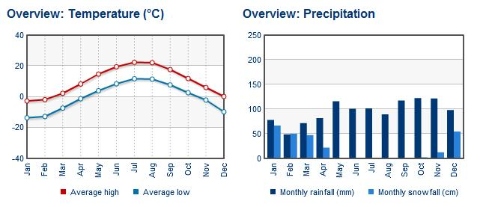
(The Weather Network, 2010)

Itinerary + Route:

Itinerary
Trip: Kayak eco-tour of the Kennebecasis River – Quispamsis to Rothesay
Day of trip | Activity Description | Location & points of interest
Day One June 22, 2011
Am 7 am flight to Saint John, NB, equipment collection | Fly to Saint John, travel to put in, lunch on mainland | Private put-in, first view of the Kennebecasis
Pm Paddle from Mainland to circumnavigate and land on Mathers Island | From put in to south side of island, up to the northern tip and back around to Long Beach camp | Private put-in, Kennebecasis River, Mathers Island, old bridge, Long Beach to camp.
Ppm Relax time on island | Learn to cook on outdoor BBQ | N/A
Day Two June 23, 2011
Am Long beach to Gondola Pt Beach | Stop at Moss Glen Falls, Stop at Gondola Pt beach for swim/Lunch | Glen Falls, Gondola Pt Ferry, Gondola Pt Beach, Clifton Royal
Pm Gondola Pt Beach to the Beach house, Gondola Pt. Road | Continue South on river to Beach house | Kennebecasis River
Ppm Erosion Talks and campfire | Talk about development, erosion, and buffer zones | N/A
Day Three June 24, 2011
Am Gondola Pt Beach to Violets cabin | Crossing from Gondola Pt Beach to Violets Cabin for lunch | Ministers face
Pm Violets cabin to Middle Beach, West side, Long Island | Navigate southern tip of island, Middle Beach | Southern tip, View of Saint John River, longest paddle
Ppm Sustainability talks, campfire | Talk about living sustainably and off the grid | N/A
Day Four June 25, 2011
Am Kayak to North point Beach, Hike to Ministers face | Kayak to the beach, take lunch up Ministers face for a change of pace | North Point beach, Peregrine Falcons protected area, Arctic plants
Pm Ministers Face to North Pt Beach | Arctic plant ID (Optional side path to Polly’s Point), Set up camp | Arctic plants
Ppm Conservation Talk, fire | Talk about conservation areas and protected species | N/A
Day Five June 26, 2011
Am Early day, hike to South Pt of Long Island | Hike along old island road to the south point for lunch | Old island road
Pm Hike from South Pt to North Pt beach | Hike along old island road back to camp at North pt Beach | Old Island road
Ppm Historical talk, Relax | Historical talk on Long island | N/A
Day Six June 27, 2011
Am Paddle from N Pt beach to Take out | Early morning paddle, pack up | Sunrise on the Kennebecasis
Pm Drive to airport, fly to Ottawa, Drive back to Pembroke | Drop off at Airport, flight to Ottawa, drive back to Pembroke | Stop for lunch in Ottawa

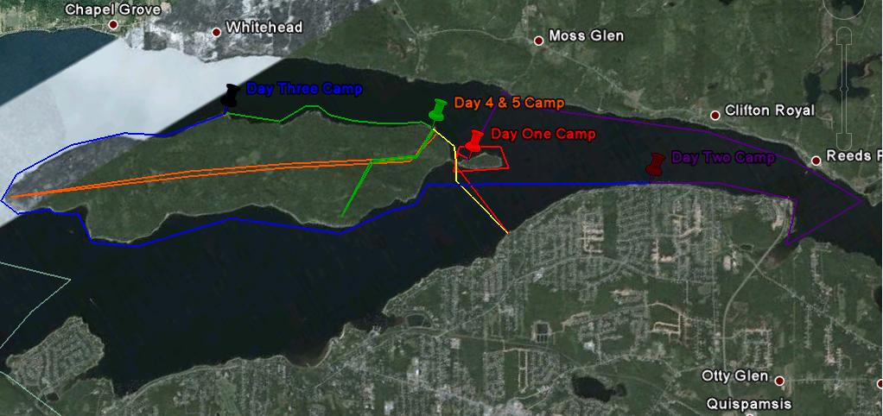
(Google Earth, 2010)

Legend:

- Red = Day one
- Purple = Day two
- Blue = Day Three
- Green = Day Four
- Orange = Day Five
- Yellow = Day Six

Day One:

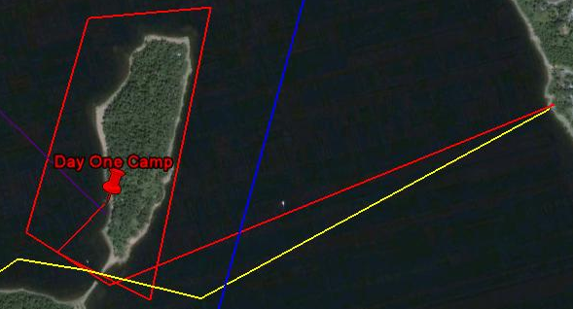
(Google Earth, 2010)
Day Two:

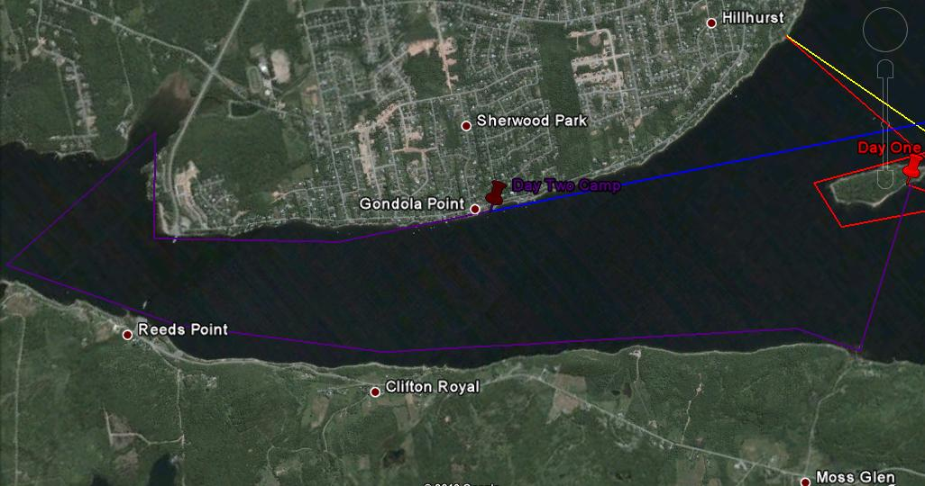
(Google Earth, 2010)

Day 3, 4 & 5

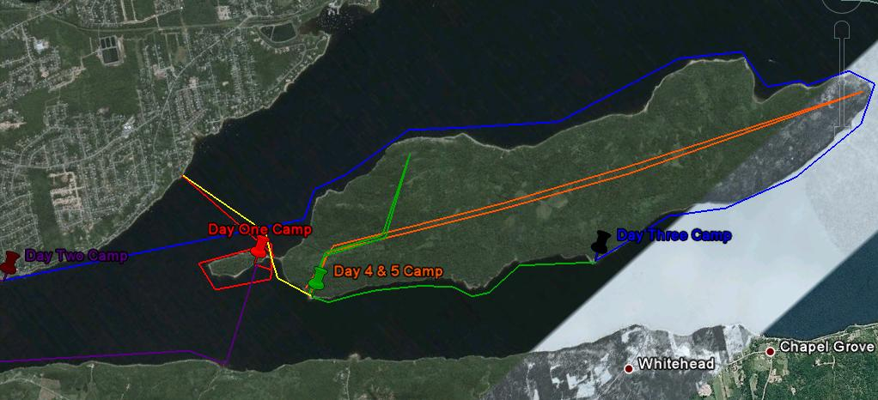
(Google earth, 2010)

Alternatives:

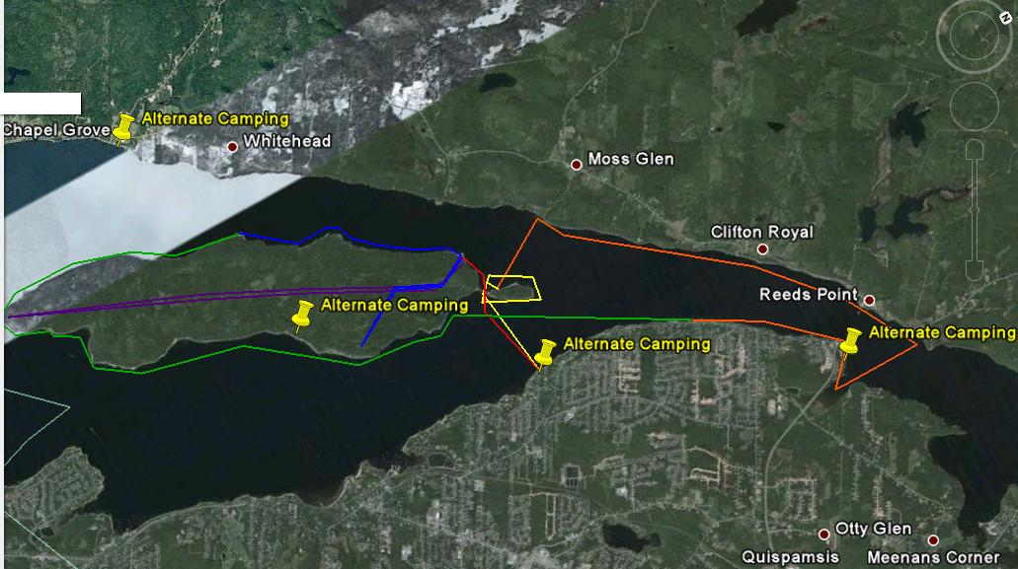
(Google Earth, 2010)

Legend:
- Red = Alternative Route Day one
- Purple = Alternative Route Day two
- Blue = Alternative Route Day Three
- Green = Alternative Route Day Four
- Orange = Alternative Route Day Five
- Yellow = Alternative Route Day Six

Expected Difficulty Spots:
There is always a risk when crossing open water, which is suggested 5 times in this trip. Days 2 and 4 are the longest kayaking, while day 5 has an extensive hike. While none of this will be on difficult terrain, these are the spots to watch for.

Participants:

- Ideal group size
The ideal size for this activity would be between 5 and 12. With not enough paddlers the day goes by more quickly, and not enough time would be filled in with activities. More than 12 paddlers is (in this open environment) more than one guide can safely handle on the water.

- Minimum Skill Level Required
The minimum skill level required for this trip is a basic knowledge of sea kayaking (how to paddle, turn, wet exit) at almost any fitness level (ability to walk and paddle long distances necessary)

Equipment:

GEAR!!!

Personal Gear List
* = optional
Sleeping Bag (+2 C) | 1
Long quick-Dry top | 1
Gloves | 1 pair
Camp shoes (ie crocs/ down bootties) | 1 pair
River Shoes | 1 pair
Bathing suit | 1-2
Short quick dry shirts | 2
Pant | 1-2
Underwear | 5
Toothbrush | 1
Toothpaste | 1
* Down Vest | 1
Toque | 1
* Journal w/ pencil | 1
Rain jacket | 1
Socks | 3 pair
First Aid Kit (Band-Aids, cohban, polysporyn) | 1
Bowl, Plate, Cup, Spork, Knife | 1 of each
* Sunglasses | 1
Sunscreen | 1
Bug Repellant | 1
* Sleeping Pad | 1
Knife | 1
Headlamp | 1
Dry bag for all personal gear | 1-3
(Virtue, D. 2010)

Potty-Pak (dry sack)
TP | 5
Paper Bags | 5
Hand Sanitizer | 500 ml
Trowel | 1
Ziploc Bags | 5
(Virtue, D. 2010)

GROUP F.A.
Sam splint | 2 | Alcohol pads | 30
Gloves | 10 pair | Bio bags | 10
Cohban | 1 roll | Triangular bandages | 10
Medical Tape | 1 roll | Non stick sterile dressing | 10
Epipen | 1 | Benadryl | 10 gels @ 250 mg
Moleskin | 2 sheets | Hand Sanitizer | 1 @ 250 ml
Sheers | 1 | Water proof matches | 2 boxes
Syringe | 1
(Virtue, D. 2010)

Group Equipment
Tents | 6 | Kayaks | 11
Paddles | 19 | Helmets | 11
Pdf’s | 13 | Bailing kits | 11
Canoe Repair Kits | 4 | PIN system | 1
FA | 1 | Tarps | 3
 |  | Radio | 1
(Virtue, D. 2010)

Cooking Kit
Dutch Oven | 2
MSR Whisperlight Stoves | 2
Fuel tanks | 6
Pot set | 2
Cutting Knives | 2
Cutting Board | 2
Spatula | 1
Strainer | 1
Hand Sanitizer | 1 @ 500ml
Large spoon | 1
Spice kit | 1
Tongs | 1
Mixing bowl | 2
Measuring cup | 1 cup
3 serving plates | 3
Briquettes | 75 dans olive jar
Tin Foil | 2 rolls
Vice grips | 1
Heavy mitts | 1 pair
Washing Basin | 3
Multi tool (with can opener) | 1
Bleach | 100 ml
Camp suds | 500 ml
Dish clothes | 2
Scrubbies | 2
French coffee press | 1
Table cloth | 1
Lighters | 3
Garbage bags | 3
Sponge | 2
H2O Pump | 3
Pristine | 50 tablet’s
(Virtue, D. 2010)

Tent Repair Kit
Nylon Tape | 1 roll
Seam Sealer | 50 ml
Pole splint | 1
(Virtue, D. 2010)

Gear breakdown:
All gear is owned by myself except for:
- MSR Stoves (Borrowed from David Virtue)
- Tent Repair Kit (Borrowed from Saint John Scout Shop)
- H20 Pump (Borrowed from Jackson Strobel)
Transportation:
Flights to and from Saint John, NB, from Ottawa, ON
Airport to Drop off shuttle provided, 30 minutes from trip Location, approximately 26 km one way.

Communication:
- Cell phones (area 100% coverage)

Budget:
 | General Expenses | Transportation | Food | Total
Personal | $100.00 | $891.85 | $54.00 | $1,045.85
Clients | $1,000.00 | $8,918.50 | $540.00 | $10,458.50
Total | $1,100.00 | $9,810.35 | $594.00 | $11,504.35
Breakdown;
Transportation for Flights only (Westjet.com)
Food 3 dollars per meal, per person
General Expenses, eg, Gas

Safety Plan:
Hazard Identification
Identified Hazard | Response
Objective/Environmental Hazards
Weather
Cooler – On the water, windy and late June temperatures | Bring extra layers, check bags for proper wind protection before trip start
Terrain
Potential for high wind | Keep to lee sides of island, paddle with the wind
Equipment
Loss of equipment | Carry 1 of every extra essential (FA kit, paddle, etc.) spread out between boats
Subjective/Human Hazards
Individual
Inadequate preparation | Have list of gear sent out before hand, check gear before trip, ask if anyone has forgotten anything
Insubordination | Keep calm and assert authority, talk to person privately, ask why, explain why certain rules are in place.
Group
Poor Communication | Make sure everyone in the group is aware of skill level and that there is no tolerance for goading because of fears
Escape Routes:
All of the below routes have accessible take out areas;
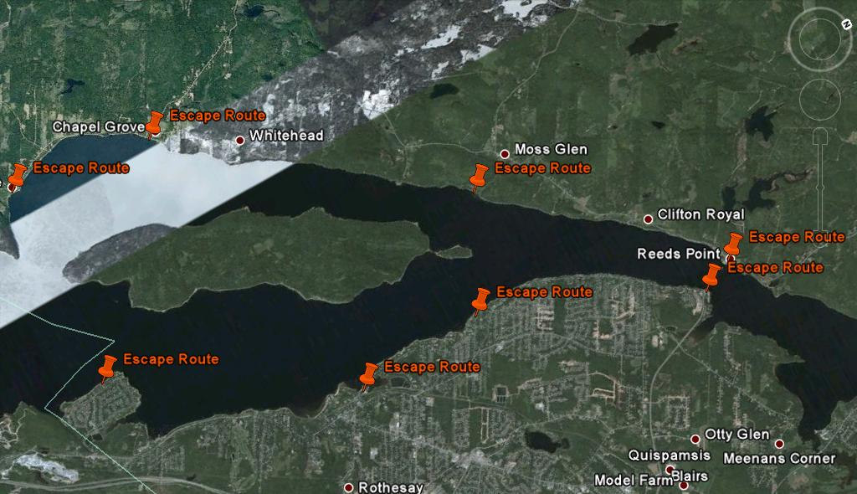
(Google Earth, 2010)

Emergency Response Plan

Contact: (Cell phones)
Coast Guard 1-800-565-1582
Mary Jo Boyce 1-506-849-3532
Rothesay Regional Police 1-506-847-6300
Saint John Regional Hospital 1-506-648-6000

Evacuation:
As soon as anything goes wrong, go to the nearest escape route!

If fully conscious – Have kayaker sit in kayak and help paddle, if able, while being towed to closest escape route, while another kayaker monitors them.

If unconscious –Put the person in the kayak in the recovery position, making sure airway is fully open and monitoring breathing, colour, and level of consciousness. Have another kayaker tie onto the conscious persons kayak to tow them to the nearest escape route, while conscious person holds onto victims kayak.

Nearest Hospital:
Saint John Regional Hospital
(506) 648-6000
400 University Ave.
PO Box 2100
Saint John, NB
Canada
E2L 4L2

References

Nature Trust Fund of New Brunswick, (2010). Retrieved from http://www.naturetrust.nb.ca/en/long-island-conservation

The Weather Network, (2010). Statistics; Rothesay, New Brunswick. Retrieved from http://www.theweathernetwork.com/statistics/CL8104900/canb0085/

Google Earth, (2010). Ruler and Place mark functions.

Virtue, D. (2010). Gear Lists. (Oct 2010). Gear list for canoe trips.

Westjet, (2010). Retrieved from https://bookings.westjet.com/meridia?posid=A7RE&sid=me2re72r9r2mv1-Ayyv:d3d6fa55c8cba3201c5555f00c9287237660b6cde6d4140a431de7fc75147341&

Canadian Coast Guard, (2010). Incident Reporting. Retrieved from http://www.ccg-gcc.gc.ca/eng/ccg/Incident_Reporting

Rothesay Regional Police Force, (2010). Retrieved from http://www.rothesayregionalpolice.com/

Atlantic Health Services Corporation, (2010). Saint John Regional Hospital. Retrieved from http://www.ahsc.health.nb.ca/AboutUs/OurFacilities/facregional.shtml

