Program Design and Development
ADN 7141
Zara, Amy, Jesse

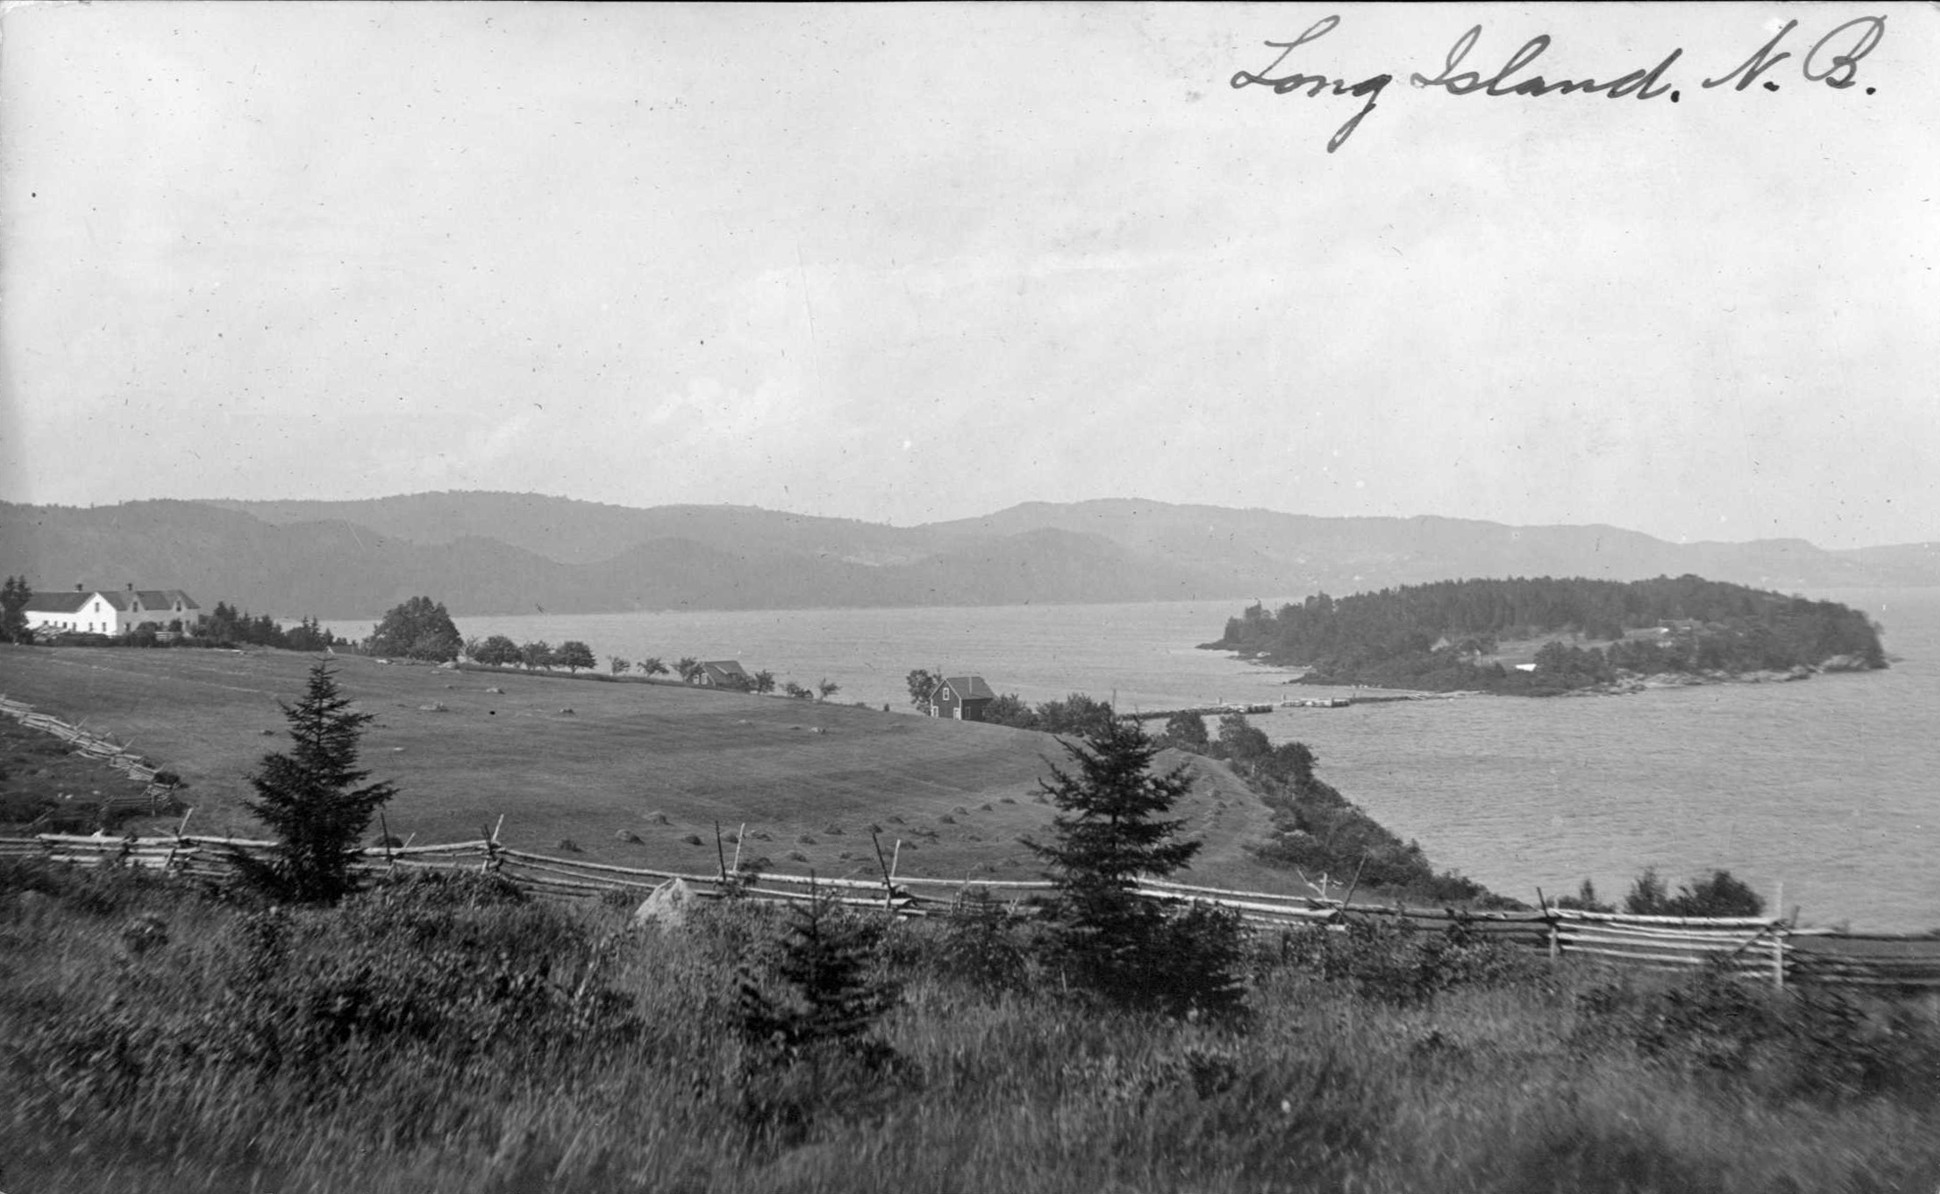
Mather’s Island Preservation Through Education

Table of Contents

Preservation through Education 3
Activities Time Line 4
Program Overview 5
Icebreaker activities 5
Mather’s Island Interpretative Hike 7
Sustainability Activity 10
Leave No Trace Campfire 12
Debriefs 14
Long Island Hike 15
Media ……………………………………………………………………………………………………….……. 19
Mather’s Island Preservation Program 20
Permission Form 21
Budget 22
Managing Risk 24
Emergency Response Plan 26
How this program ties in with New Brunswick Curriculum 29
References 32

The Mather’s Island Preservation Project

Preservation through Education
The Mather’s Island Preservation Project is a 2-day educational program designed to teach students about the natural environment and living sustainably. The program is specific to two islands on the Kennebecasis River near Saint John, New Brunswick. Mather’s Island is home base for educational activity, with a hiking tours being conducted on Long Island.
This project has been designed for the shareholders of Mather’s Island Inc. to be able to share the rich history, the pristine natural environment and the sustainable way of living of the island, and to educate the students of New Brunswick about why these things are important. As well, kinesthetic teaching styles will be employed, to engage students in hands-on tactile activity. Not just educating them in a classroom, but also taking them into the environment they’re learning about, so they can appreciate their spaces and learn about the importance of preservation first hand- not because somebody has told them to, but because they want to.
Why is a getting a kid outside so important?
Richard Louv, the author of “Last Child in the Woods: Saving Our Children from Nature-Deficit-Disorder” and “The Nature Principal” says “An environment-based education movement--at all levels of education--will help students realize that school isn't supposed to be a polite form of incarceration, but a portal to the wider world.” Mather’s Island Inc. holds the same beliefs, that on-site education, with tactile activities can engage students' interest and passion .
“Yeah, sure, technology gizmo’s are all well and good, I use them…but sooner or later these kids have to realize their cell phone won’t feed them or give them a place to live. That’s what we want to show them…there are places still worth living in, but we need their help to keep it that way.” Sandy MacKay, M.I.inc shareholder.
Nature is our future; without it the world would be a pretty dismal place. But it needs to be a sustainable future. “The future will belong to the nature-smart—those individuals, families, businesses, and political leaders who develop a deeper understanding of the transformative power of the natural world and who balance the virtual with the real. The more high-tech we become, the more nature we need.” (Richard Louv, 2012)
Preserving the land is paramount, but it needs to be done in a way that is usable. It doesn’t instill love of a place when it is fenced off and you can’t touch any of it; nature should not be made into a museum. The historic nature of the program also ties kids to some of their very-close-to-home roots, which helps with the reverting to an “old” way of doing things that’s becoming the “new” thing.
The next pages detail everything you need to know to get this project up and running, from introductions to activities and everything in between.

Activities Time Line
Time | Activity | Description |  | Relation to Theme
Day One
10:30-11a.m. | Arrival at Shipyard Road put in | Pick up of students and faculty in boats by Mather’s Island Inc. |  | Safe access to pristine environment
11 a.m. | Arrival at Mather`s Island | `` |  | ``
11-11:30 a.m. | Introduction/Icebreakers | Briefing for trip, guidelines |  | Environmental and cultural preservation
11:30-12:30 p.m. | Historical tour of Mather’s island | Exploring historic buildings, climates of the island, island as a whole |  | Cultural history preservation of Mather’s Island
12:30-1:30 p.m. | Lunch | `` |  | ``
1:30-3 p.m. | Sustainable living demonstrations | Including activities for students and talks on Solar Energy, farming etc. |  | Environment preservation/sustainable living
3-5 p.m. | Organization of sleeping quarters | Have groups split into different historic cabins on the island |  | Cultural history preservation
5-6:30 p.m. | Supper | Provided by Mather’s Island Inc., fresh produce, livestock/eggs |  | Sustainable living
6:30- 10 p.m. | Leave No Trace Fire Debrief | How to do a mound fire, songs/relax |  | Environmental preservation
Day Two
8-9 a.m. | Breakfast | Provided by Mather’s Island Inc., fresh produce, livestock/eggs | Sustainable living
9-9:30 a.m. | Allow student`s time to get ready for the day | `` | ``
9:30-11 a.m. | Mather`s Island Boat Tour | Ferry students from Mather’s island to Long island using the remains of old wharf left over from when the islands were settled | Cultural history Preservation
11 -2:30 p.m. | Hiking tour of Long Island (inc. Lunch) | Look at the unique biodiversity of Long Island, plant ID, wildlife ID, Working with NTNB:LICP | Environmental education in a pristine environment
2:30-3:00p.m. | Debrief, boat back to Shipyard Road put in | Drop off at Shipyard Rd | Safe access to pristine environment
Departure

Program Overview
Who I am
I am Mary-Jo Boyce, one of the share holder’s of Mather’s Island. I am an Occupational Therapist and environmentalist seeking ways to incorporate my skills and favourite activities. I love the outdoors, and I want to find a way to introduce and engage students in a life-long commitment to the environment.
Certifications: Wilderness First Responder, Boat operator’s license, B.Sc.OT (Occupational Therapy)
Experience: Worked in schools 20+ years with learning disabled, 18 years teacher experience homeschooling, instructed Fundy Home Educators group outdoor learning course for 3 years, BOW 4 years, Envirothon mentor/instructor 3 years (Forestry, wildlife, aquatics, soils)
Who we are
Mather’s Island Inc., an incorporated group of 10 shareholders dedicated to preserving the history and natural environment of Mather’s Island while living sustainably.
Mandate: To provide safe access for environmental education in a pristine environment.
Goal: To host group trips on day adventures and overnight excursions; to highlight the importance of environment preservation and cultural history of Mather’s Island NB.
Overview:
- 2 day program for high school students
- Day one: Morning, history of Mather’s island in an outdoor setting (tour of island, buildings, hike). Lunch, fresh eggs and produce from island. Afternoon, Sustainable living demonstrations.
- Overnight in historic buildings on Mather’s Island
- Day two: Boat tour of historic put-in on Mather’s Island to Long Island. Lunch, fresh produce and wild edibles from Long Island. Afternoon, hike on Long Island, looking at plant ID, and biodiversity.

Icebreaker activities

Activity 1: The rain barrel effect
Time: 20 minutes
Theme: Preservation through education – Biodiversity sustainability
Goal: Break the ice, introduce sustainability and preservation in an easy to understand, active and fun format
Where: Mather’s Island, Long beach
Description of activity:
Set up: Pick 3-5 students to be a local animal (deer, racoon, squirrel, rabbit...etc.). Divide the rest of the students into resources; Food, water or shelter.
Food: Hands on stomach
Water: Arms out to side, moving like a wave
Shelter: Arms above head, forming a “roof”
Play: Keep the local animal in the middle and tell the resources to scatter, but not out of sight. On your say, the local animals have to find a resource in order to survive (resources stay in one spot). Only one animal per resource. Once they’ve tagged a resource, the resource will become a local animal. The animals congregate again in the center and the resources scatter.
Game continues until there are more animals than resources; if an animal does not find a resource, it “dies” and becomes a resource itself.
Game continues as long as you want to continue showing the cycle of overpopulation/over crowding
Debrief: Describe the “rain barrel effect”, of how one area can only support so many organisms while being sustainable. Food, water, shelter and space are needed to survive, and how nature manages the resources. When there are a lot of resources, the area could support a lot of animals. When the animal population went up, there weren’t enough resources to for all of the animals to survive. Tie in with human population and consumption, and discuss “what are you doing to keep our world sustainable?”
Activity 2: Group web of life
Time: 15 - 20 Minutes
Theme: Preservation through education – Everything is connected
Goal: Get to know you/name game, show how everything is connected
Where: Mather’s Island, Blue tarp kitchen
What you’ll need: Ball of string, rope, or yarn
Description of activity: Everyone stands in a circle. Facilitator has a ball of string, and starts by saying their name, a fact about themselves (favourite colour, where they’re from, etc), and what they like about being outside. The facilitator then throws the ball to another person across the circle, but holds onto the end of the string, and that person then says their name, a fact and what they like about being outside. This is repeated until all participants have a piece of string. Try and repeat everyone’s name. Do different things with the string – pull on it, etc, to show how the string connects us.

Debrief: Explain how everything is connected and how the little things we do affect the environment, positively or negatively. Ask students how they can ensure what they like about being outside will still be available in 10, 20, 30+ years. Provide historic examples of what fun outdoors things tie in with the Island and the importance of being outside (like with the Orphan’s Asylum).

Mather’s Island Interpretative Hike
Activity: Historical tour of Mather’s Island
Time: 1 hour (11:30am -12:30pm)
Theme: Preservation through education – Island history
Goal: Compare and contrast the history of the island (first settler to current day residents). Show how old practices can be combined with modern day living to provide a sustainable future. Have students engaged, interactive and interested in the rich history of the island.
Where: Start at Long Beach, to South shore, then north shore, with side path’s for points of interest.
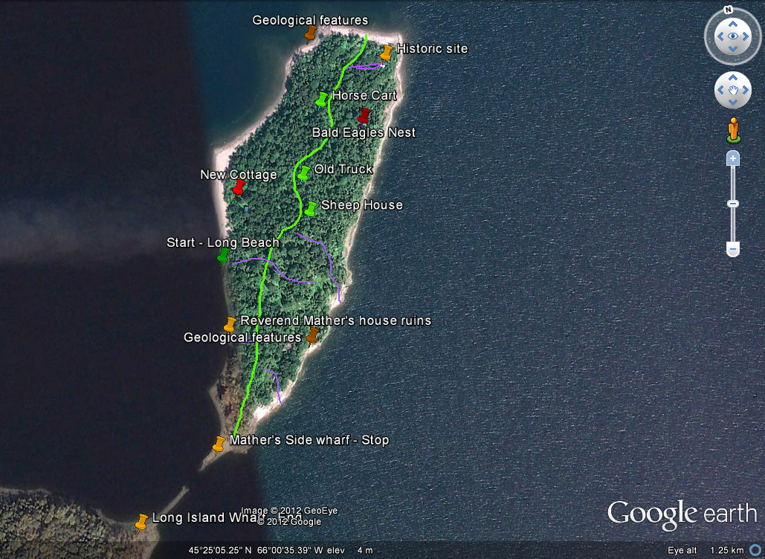

What You’ll need: Booklet of historic facts prepared by Fin MacKay-Boyce from http://mathersisland.wordpress.com/.
Short history of Mather’s Island: Mather’s Island is 35 acres of woodland, fields and cottages – some well maintained and some run down (MacKay-Boyce, 2011). It was first settled in 1786 by Henry Benter, who was given the land by the British government. The harsh climate and relatively poor soil and harsh climate forced many of the settlers away from the area. In 1885 it was purchased by Reverend Richard Mather’s for 350$ who ran the Wiggins Male Orphan Asylum. In the summer Rev. Mather’s would bring the boys to the dormitory on the island (How does that tie in to what we’re doing now? Education in the outdoors). The Reverend passed away in 1910, 9 years after the boys stopped coming to the island, and was passed to his son, then his daughter-in-law. It was passed on to two different families before being bought by Mather’s Island Inc. In 1975, where it has been inhabited by Jim Clark ever since.
Description: A historical tour of Mather’s Island and it is scheduled to be one hour long. The walk can be based on the main trail starting at either side of the island, and the side trails can be followed to visit points of interest. The new houses and communities will also be shown and can be contrasted with the old houses and communities. Explore the new houses and old houses that have been restored. For safety purposes, a distance of 3 meters must be kept from the old houses in disrepair.
Points of interest: Old broken down orphan houses used in the summer by the boys of the Wiggins Male Orphan Asylum, the beach on the south side with the remains of the two wharfs, a beach where boats have landed for hundreds of years, an old horse cart and a sheep house that have been left from long ago.
Lot #37, once the home of Henry Betner (the first settler in 1786) can be pointed out and more information can be given on the early communities of the island. The main trail and its branches will take the students through mixed forests, marshes, and to the sandy beaches and rock piles. The permanent resident lives at the north end near the main trail, and the students will notice the artful and environmentally minded mix of people that now live on the island. This will be seen in the island dwellers homes: Many practice a variety of green living and sustainable farming projects. These include the solar panels on the island, sustainable gardens for organic food, rain barrels, bikes, canoes, kayaks, fireplaces, and wood stoves. The art and design of the homes will show the cultural values of Canadians in the present and history of each families home and will reflect on the evolving face of Canada’s culture.
Expansion opportunities:
- Have students write a journal entry of what they think an orphan from Saint John would have felt coming to the island.
- Restoration project
- Trail building or upkeep
Debrief: Why is preserving history important? How can you tie in what you’ve learned to present day? Could you implement it in your community? What was the coolest thing you learned about the island? Could you live like the first settlers on the island? Why or why not? Could you live like the current occupants? Why or why not? What are “necessities”.

Sustainability Activity
Theme: Preservation through Education
Time: Program will run from 1:30 p.m. to 3 p.m.
Where: Mather’s Island
Introduction
What is sustainability?
Sustainability is based on a simple principle: Everything that we need for our survival and well-being, either directly or indirectly. Sustainability creates and maintains the conditions under which humans and nature can exist in productive harmony, that permit fulfilling the social, economic and other requirements of present and future generations.
Why is it important?
Sustainability is important because all of the choices we pursue and the actions that we take today will affect everything in the future. We need to make sound decisions at present in order to avoid limiting the choices of generations to come. What we do as individuals directly impacts the surrounding environment, even though some things may seem to have a minimal impact; when 7 billion people are contributing it becomes quite substantial. The impacts of what we do won’t disappear overnight but the first step in solving the world issue is through education. For the most part people just don’t know the impacts they are having on the environment - making food, washing clothes, driving to school - all of these this have a negative impact. Mather’s Island residents have realized this and have put steps in place to try and maintain a sustainable environment. Mather’s Islands is quite unique in the biodiversity that exists on it; many of the eco-systems are very sensitive. (More Information about the eco-systems during the Hiking Tour)
How can we become more sustainable?
Sit the group in a circle. In the middle, provide a bristle board and markers; have them write down ideas of how to be more sustainable. Allow 10 minutes for this activity.
After ask the group about things they have seen being done around their community or things they do at home that relate back to the issue of sustain ability.
Bring the group to the solar Panels located on the Island:
Solar panels provide clean renewable energy that converts the sun’s ray into electricity. These panels do not require any fuel and release no emissions. According to statistics published by Solarbuzz Consulting, 71 percent of the electricity produced in the United States in 2000 came from fossil fuels, adding to the world’s burden of CO2 emissions and other forms of air pollution. Another 20 percent came from nuclear reactors, which have the problem of radioactive waste. Because solar panels produce energy from sunlight, they produce no emissions, greenhouse gases or waste. This is something usually done on a large scale with sustainable costs, thought it is a good thing to look into for the future.
How to make these implementations around your home?
Location: Garden on Mather’s Island
Not all sustainability needs to be this extreme; it is easy to do things on a smaller scale. Some things can easily be done around any average house hold. This doesn’t mean going out and buying things that are labeled as eco-friendly, just minor changes in anyone’s life style that can cut down on emission’s being released or resource consumption. Different Topics to talk about include:
- Reusing materials (ex. buying a container instead of using zip locks, buying second hand)
- Creating a compost
- Recycling
- Making your own cleaning products (ex. Using vinegar as window cleaner)
- Create a small garden
- Planting Trees or other plants
- Getting involved in local environment groups (Students of New Brunswick need to do a mandatory 40 hours of community service)
Activity
Creating a Rain Barrel that student’s can bring back to their school. Have all parts to the rain barrel cut up and measured so students just need to put it together.
(See Document in Appendix A on how to create a rain barrel)

Leave No Trace Campfire
Building a Mound Fire
Every person enjoys a good fire to conclude day, this will allow for a learning work shop, creating a perfect atmosphere for debrief allowing for some reflection and fun. After dinner and clean up students will go back to their cabins to change into warm clothes for the rest of the nights activities.
First part of the night will consist of creating a Leave No Trace mound fire. While students are changing facilitators will get all the necessary resources that the students will need to create a mound fire. Go over a briefing on how to create mound fires and then have students to work together and create their low impact fire pit.
Materials Needed: Shovel, Garbage bag, lighter
Instructions:
Step One: Break students up into two groups or let them decide what group they want to go in. Group A will be responsible for creating the mound fire while group B goes to collect wood. Before groups split off go over why having a low impacting fire are important and the steps to create a mound fire.
- Dig a hole using the shovel on an already impacted area(making sure to leave the soil close at hand)
- Line the hole with the garbage bag
- Transplant some soil onto the garbage bag, making sure to not entirely cover the garbage bag; leave all corners sticking out
- Build up the fire on top of the dirt mount making sure to keep it small so that it doesn’t burn the garbage bag and creates less impact
- Once the fire is done poor water on it to make sure it is out completely have group B then pick up all corners of the garbage bag flipping contents into the hole
- Fill the hole in with extra soil and stomp it down so it looks as though there was nothing there
Note: Remind students to pick up only dead branches they find and sticking closely to paths that are already created. (Also if everything is to wet make sure to have another wood source)
Step Two: Supervise students creating the mound fire and make sure to answer all questions they may have. Gather the group together once the fire is started and proceed with other activities planned.
(The Above activity are based on weather permitting)
Winter: During the winter months it would seem impossible to create a mound fire, by using a fire pan it still allows for a similar experience that still follows the leave no trace principles.
Rainy Day: Instead of going outside for a fire lesson the students will gather around an indoor wood stove, which will include an introduction to what it is and the different benefits of a wood stove. Students will then be able to make homemade hot chocolate which allows students to see just how efficient a wood stove is. This create a nice cozy atmosphere for debrief to take place.

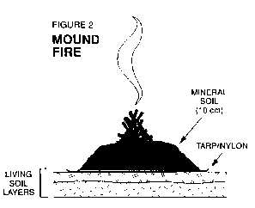

Debriefs
Debriefs are very important in the learning process of most individuals. In any program it is good to reflect multiplies times throughout the day, making sure to re-enforce what students are learning. This should be done after every activity to make sure they keep reflecting. The most important debrief is at the end of the day, giving everyone the chance to talk and reflect. This can be done a number of ways; below are multiple debrief ideas:
Debrief one
Materials need: Birch bark off a dead tree, writing and colouring tools
Description: Give each student a piece of birch bark and some writing and colouring tools. Student will then draw or write about one thing they learned that day, making it as creative or as simple as they please. Not only does this creates reflection on the day but then becomes a take home souvenir. Once students finish up allow time for them to share with each other.
Debrief two
Materials Needed: None
Description: Rose, bud, thorn. Have students sit in a circle. Rose represents something they liked about the day; bud represents a piece of information that the student may have known already and the Thorn represents something they would like changed about the program or something that they didn’t like. This not only allows for reflection but also gives insight to good things about the program or things they may want to change for the future.
Debrief three
Material Needed: A long rope
Description: Place down a long rope on the ground the rope that represents a meter. One end is strongly agree, one end is strongly disagree. The facilitator will then read a statement, a quote, play a song or read a poem that contributes to the theme of preservation. Students will then line up on the rope and explain why or why not they agree with that statement.
Note: Think of a challenging topic that is not extremely one sided to allow for good discussion
Debrief Four
Materials Needed: None
Description: Using the five senses allow each person to reflect smell, taste, sight, feeling and sound. Start off with one sense and allow each person to reflect on it before moving on. This is a good activity to do on the last day to have everyone reflect on both days.

Long Island Hike
Activity: Hiking tour of Long Island

Time: 3.5 hours (11:00am – 2:30pm)

Theme: Preservation through Education

Goal: Introduce students to a preserved and diverse eco-system, gain knowledge around plant and wildlife identification, and be active in the outdoors

Where: Long Island, boat launch to Minister’s Face

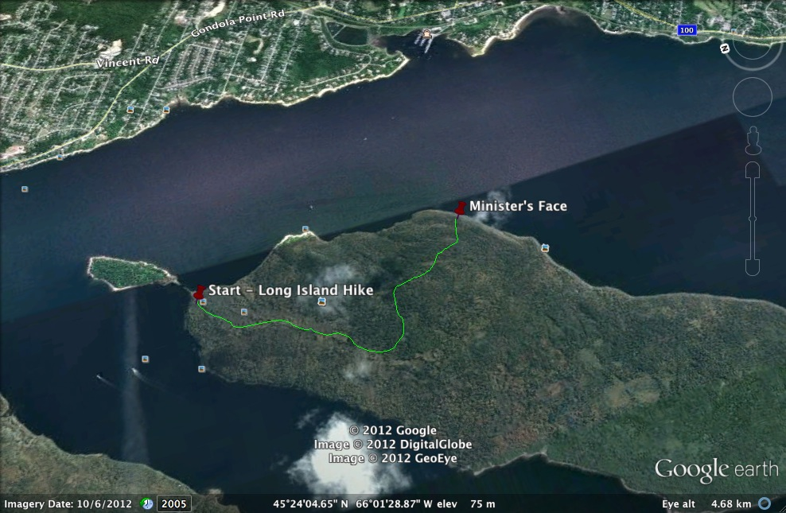

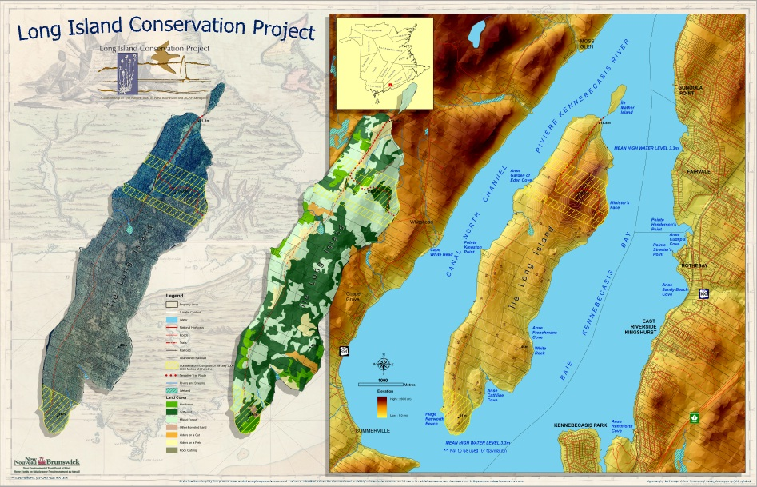
(NTFNB, 2012)

Distance: 5 km total

Why Long Island is available for us to use today – Nature Trust of New Brunswick: The Long Island Conservation Project: “The Long Island Conservation Project was a multi-year initiative aimed at securing and managing land on Long Island for future public access, open space and conservation. The Nature Trust of New Brunswick, in a joint undertaking with the Atlantic Coastal Action Program Saint John formed the Long Island Committee, a group of volunteers committed to securing and protecting major portions of this landmark for the future.” (NTNB, 2012) The LICP has 364 acres currently protected on Long Island, with 255 of those on Minister’s face. The NTNB is planning to come back to this project soon for potential expansion. Donations are welcome.

Description of Long Island: Long Island is 7km long and 2 km wide. It is beside the Kennebecasis river, and at 2,190 acres is the largest island in the Kennebecasis or Saint John river systems. There is a 200ft cliff called Minister’s Face, a small waterfall, beaches and hiking trails that link the remains of loyalist settlements (some originating in 1785). Minister’s face is home to a breeding site for Peregrine Falcon and rare arctic flora such as livelong, saxifrage and Alpine Woodsia. The island has mature forest, regenerating forest, and treed marshes. There are Red Spruce, Balsam Fir and mature Eastern hemlock on the island, as well as Manitoba Maple so there are lots of learning opportunities for students.

Description of Activity: The focus of this hike is biodiversity, and plant and wildlife identification. During this hike we will stop at various sites to talk about different native plant species, spot wildlife tracks (hopefully wildlife), discuss why native species are important (biodiversity) and have a leaf ID game. Lunch at Minister’s face.
What you’ll need: Leaf ID book (provided by MIPP), GPS, compass, whistle. Ensure all students have proper footwear (sneakers are fine).
Leaf ID game:
Description: This is an activity that will give students a chance to notice and study a forest in different ways. It will give them a basic knowledge of tree identification in the area and a good starting point to build on. With this new knowledge of trees and leaf identification, students will be better able to understand preservation.
What you’ll need: List of deciduous OR coniferous trees on Long Island, pictures of leaves, ID features. 8 -10 manila envelopes.
How to play:
- Split the class into groups of 2-3 depending on the size of the class
- Give each group a list of 3-5 deciduous or coniferous trees in the area with a picture of the leaf and identification features as clues (If they are a more experienced group and feel like a challenge give them only identification features and no pictures)
- Give each group a large envelope to put the leaves in
- Allow 10 to 20 minutes to collect as many of the leaves they can along the path and ask them to return when they hear one whistle blast
- Walk around the area to see how the groups are doing as they’re collecting
- Once they’re done give them about 5 minutes to check the ones they found and match them with the list
- Check in with one group at a time to see how they did and to answer any questions they might have
Debrief: Talk to students about the different plants in the area – have you heard about different ways to harvest trees? Which ones are viable? Why or why not? Different uses (food, shelter, economic) for different trees. Difference between deciduous and coniferous.
Overall Debrief: Once back at the boat launch, discuss what we’ve learned on the hike and go over why biodiversity is important. How can you ID tree’s at home and what can you do to conserve them? Link to NTNB website for instructors; how to get involved. http://www.naturetrust.nb.ca/wp/?p=238.

Media
Mary Jo Boyce and Sandy Mackay are presenting this type of tour more as a learning experience and less about trying to make a profit. Long Island and Mather’s Island have very sensitive eco-systems making it impossible to have large amounts of tourism on the Islands. Information will need to be presented to get schools on board to send students to Mather’s Island as part of their curriculum. The following pages contain information that Mary Jo and Sandy can further present to different high schools. It will allow for high schools to get a good understanding of what this program is about and how it can benefit a student’s learning.

Mather’s Island Preservation Program

Dear (Insert Principal's Name),
Mather’s Island Preservation Program is unique to the area. It will allow students to get a hands-on learning experience while looking at topics such as conservation, sustainability and New Brunswick history. In general terms, this course is designed to provide students with greater insight, appreciation, concern and knowledge about the outdoor environment and the opportunities that it holds for educational, recreational and economic benefit in New Brunswick and around the world. The Mather’s Island Preservation Programs ties into a number of programs related with the school board curriculum that include Outdoor Education, Environmental Science, Leadership, History, and Sustainable living. All courses will be offered to New Brunswick high schools across the province. Please find attached a detailed Activity Plan followed by the proposed Two Day Schedule. Other documents required for this program will be forwarded following your acceptance of the Program, including Parent Waivers, In-Class Preparation Activities and Teacher Checklists.
Thank you for your time.
Sincerely,

Mary Jo Boyce & Sandy MacKay, M.I. Inc. Shareholders

Permission Form

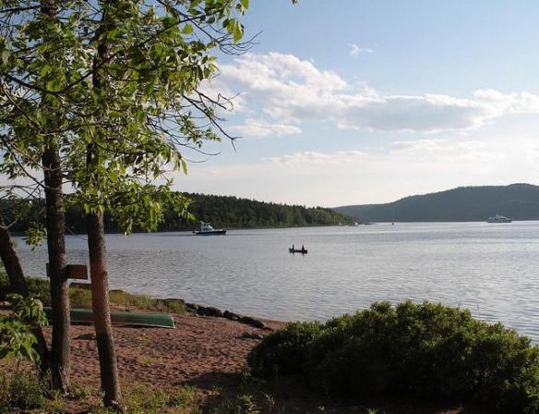

Dear Parents,
Mather’s Island Preservation Program is a unique program that allows students firsthand experience through history and conservation. This is a two day long time in which time students will be driven by bus to Mather’s Island docks then they will be boated to Mather’s Island. They will spend time on both Mather’s Island and Long Island. Provision of these two days will include sleeping bags and housing, plus all meals will be provided. Students should bring water bottle, sun screen, proper clothes and shoes.
Students Name: _____________________________________________
Date: _____________________________________________________
Emergency Contact Information: _______________________________
__________________________________________________________
Payment of $40.00 is required at the time of student’s arrival

Budget
There are a few things to take into account when creating a business, it is important to look at all possible costs associated with opening the program. Below is a very basic budget report that includes the basics for how much to charge each student attending and the price of having a student for an overnight trip.
Revenue:
Grant: $40,000 Environmental Education Grant from the NB Wildlife Trust Fund
Student Minimum: 15
Cost per Student: $40
Total Revenue Minimum: $600
Student groups per week: 1 (first year)- 2 (second year)
Revenue made in first year: $62,800
Revenue made in consecutive years: $85,600
Note: This is all dependant of number of students in each class. In order to be able to create revenue and a manageable price is means that there must be at least 15 students per class. Lower amount of students would need to increase the cost to the individual student.

Start up costs and annual costs:
Building: None
Equipment Needed: $4,000 (Plates, Cups, and Sleeping Bags)
Food per person: $3 per person per meal (3x4 = $12)
Food per group: Meal cost x number of meal x group (3x4x15= $180)
Food cost per year: Groups per week x cost of group x weeks in a year (1x180x38=$6,840)
Signage: $1,000 approximately $50 per sign
Staffing: 2 full time seasonal staff, $46,000 total
Insurance: approximately $2,000
Gas per year: $1.20 per litter x 80 litters (based on 250km per tank) approximately 26 trips per tank. Will need to do 208 trip (208\26=8). Will need to fill up 8 times a summer ($96x8=$768)
Safety Inspection/contractor: Building inspection $1000.00 good for 5 years
Maintenance: $5,000
Start up Costs: approximately $8,000
Yearly Costs: $68,608 first year
Consecutive years: $67,448

Other sources of income can include different bursaries and grants from the government, but of course all of these will need to be applied for.

Managing Risk;

It is always better to prevent and manage risk rather than have an incident occur, though these things will happen. Here are our recommendations of things to consider about for risk, some systems to implement and an Emergency Response plan, in case an incident does occur.

Risk Considering:
- Legal
- Travel
- Equipment
  - Maintenance
- Degradation of the natural environment
- Wear on buildings
- Mitigating risk (finding it before it becomes a problem)

Things to implement:
- Legal
  - Insurance: While the details of insurance are up to Mather’s Island Inc., we recommend at least Small business insurance with workplace safety, to make it easier for the schools to join in the program with minimal risk to either the school or Mather’s island.
  - Have employee insurance (future consideration)
  - Waiver: Have a waiver for all participants sign waiver forms BEFORE they come onto the island.
    - Have a simple, straightforward design so the student/instructor/parent KNOWS what they are signing…an assumption of risk/exclusion of liability.
    - State the risks inherent to the activity (crossing a body of water) as well as ancillary risks (such as tripping). Include negligence as an inherent risk to protect your guides.
    - Witness the signature of the student, whether it is you, the teacher or another student. Make sure they know what they are doing.
    - Ensure you are familiar with the document to be able to state what is on it clearly.
    - If a student(or parent) has not signed a waiver, they are not to set foot in or on Mather’s Island Property
    - Keep each waiver for 7 years.

- Travel
- Valid boat license
- Current PFD’s fit to student (retire after 5 years of use
- Back up fuel
- Paddles

- Equipment
- Procurement: Though not much equipment purchasing is required, make sure proper research is done when buying new equipment
- Maintenance: Make a schedule for maintenance of ALL equipment to ensure it is usable and safe at all times.
  - Boats, inc. content. Check before and after each use, keep checklist inside boat. Check motor, fuel, seats, hull, and paddles. Make sure it contains FA kit, flashlight, bailer, compass, whistle, the boat driver’s licence and the necessary number of PFDs.
  - Buildings. Clean up after each use, routine maintenance weekly or as needed. Keep checklist in each building to ensure work has been done. Check windows, doors, beds, floors, walls, ceilings.
  - Any rope for fraying
  - Cooking supplies. Clean after each use. Check fuel.

- Degradation to the Natural environment
- Because of the size of the island and the sensitivity to some plants on both Mather’s and Long Island, we are recommending that the maximum number of trips per week is 2, and the maximum number of students at a time is 15.
- Implement a system (perhaps into the waiver) of leave no trace principals and go over the principals with students. Leave no trace is a principal of take only pictures, leave only footsteps. For more information go to http://www.leavenotrace.ca/home.

- Wear on buildings
- Strict no vandalism policy on old buildings – they are historic.
- Weekly maintenance
- Rotate sleeping quarters between buildings, so no one building gets worn out.
- Have at least 2 periods per year for major upkeep, renovations and to give the buildings time to relax, as it were.

- Mitigating risk
- Have weekly inspections of the entire island to find potential hazards. Keep a clipboard to detail these inspections, manage risk accordingly and as soon as it is found. If a hazard is found but not dealt with right away, document it and set a date to manage the risk as soon as possible.

Emergency Response Plan

Purpose
The next few pages contain information needed to asses and execute a response to an emergency. Having continuous exposure to working in an outdoor environment will create maximum potential. All staff should be familiar with content to ensure both staff and student safety. An emergency response plan will serve to mitigate costs, personal and economic, associated with emergency situations by:
- Limiting and containing the extent of the emergency
- Limiting negative experience image
- Assessing and preventing future incidents
- Ensure documentation of the entire emergency
Emergency Definition
An emergency will be defined, for the purpose of this plan, as an incident that threatens the company’s assets, employees, property, or clients that cannot be dealt with using existing resources. The existing resources are the current resources of the guide in the field responding to the incident. (While minor injuries [cuts, etc.] are not categorized, they still have to be documented)
- Moderate Severity: Substantial injuries (ex. Broken arm) of a non-life-threatening nature, incidents that have substantial consequences to the clients or organization.
- Severe: Injuries of a life-threatening nature, Incidents that have a substantial effect on staff, clients and the company.
- Catastrophic: Multiple fatalities, massive consequence to the organization.
These levels are used to give a sense of the severity of the incident and to communicate quickly with the level of response needed for each incident by this, and other systems. The levels indicate severity, but the level of response will also vary on urgency. In any emergency the following contacts will be informed.
- Owner of Mather’s Island Preservation Program (will be with group)
- Local emergency response
- Emergency contact located on signed form
- School
Communication Process

All documents that will need to be filled out in case of Emergency will be found in appendix B

Note: All documents are legal documents and can be held accountable in court, ensure that all document are filled out and accountable

Hazard Identification:

Objective/Environmental:
- Weather:
  - Rain—make sure all students are wearing proper clothing activities will not student down solely on rain being a factor, the facility will have extra cloths to make sure students are not uncomfortable.
  - Thunderstorm— Lightning poses threats such as fallen down trees and the risk of being electrocuted. Keeping people in the main lodge will help eliminate risk; other programs will need to be created for waiting periods.
  - Strong Winds- Anything past 60 km per hour becomes too dangerous for student and will need to seek shelter. Thunderstorm process applies.
  - Heat—Risk of dehydration and sun burns. Keep large water jugs and bottles of sunscreen and different points where students can easily asses these necessities.
  - Snow—Dependant on the amount students will still take part in planned activities extra clothing will be provided to students who may not have packed right.
- Terrain:
  - Island- the island itself poses a big challenge if someone gets hurt it will take more time to evacuate them. Being constantly surrounded by water could be potentially hazardous to age group sneaking out at night. To minimize this students are required to sign waivers that will hopefully deter them from sneaking out and hurting themselves.
  - Hiking- Most of the activities include going on planned hikes. Students not used to these activities may find the 1-4 hour long hikes challenging. Allow for water and snack breaks along the way to the destination. Lunch is included in the long hike.
- Other:
  - Wildlife encounters— Mather’s and Long Island will not have larger wildlife such as bears, wolves, and moose, but make sure that students apply by leave no trace principles so that smaller animals are not attracted.
  - Sickness— All staff members will be train in either WFR or standard first aid. All actions dependant on the situation.
  - Mental- unable to complete the program due to psychological issues will need to be sent home and not help against their will
  - Allergies—Mitigated by carrying of various antihistamines and other interventions ex Epi-Pen, proximity to critical care
  - Student issues- having team building exercises on the first day allow students to choose rooms

How this program ties in with New Brunswick Curriculum

Preservation through Education; A 2 day program learning about the natural environment, living sustainably and the history of Mather’s Island, NB.

Canadian History 122;
Link for more information; http://www.gnb.ca/0000/publications/curric/CanadianHistory122.pdf
Course outcomes:
(Andrews, Chapman, Fitton, Parker, Petrie, Smith-Graham, Smith, 1998)

Why it ties in with our design program;
Mather’s Island incorporated wants to provide a safe access for environmental education in a pristine environment on a small scale. Providing 1-2 day trips highlighting the importance of environmental preservation and cultural history of Mather’s Island, NB.
Direct Learning outcomes related;
Theory
- Historical interpretation skills
- Understanding the importance of history in Mather’s Island and Long island, New Brunswick
- Tying the past with the present; First settlements to current day NB
Outdoor Pursuits 120;
Link for more information; http://www.gnb.ca/0000/publications/curric/Outdoor_Pursuits.pdf
Course outcomes:
In general terms this course is designed to provide students with greater insight, appreciation, concern and knowledge about the outdoor environment and the opportunities that it holds for educational, recreational and economic benefit.
- Students will demonstrate a knowledge of the importance of natural resources.
- Students will demonstrate ongoing appreciation for these resources.
- Students will master the necessary technical skills relevant to the unit activities.
- Students will demonstrate appropriate safety procedures.
- Students will demonstrate outdoor living skills for future leisure pursuits.
- Students will demonstrate the acceptance of responsibility for self and for others as related to program planning and the administration of the plan.
- Students will demonstrate a willingness to accept a leadership role.
- Students will participate in an interaction between peers and with the instructor.
- Students will participate in an evaluative process related to performance, planning, implementation and roles of responsibility involved in out-tripping experiences.
- Students will demonstrate their ability to solve problems related to the course.
Examples could include the areas of safety, technical skills and group dynamics.
(Fraser, Fraser, Roach, Faulkner, Deweyert, Woodworth, Norman, Crossman, Taylor, 1995)
Why it ties in with our design program:
Mather’s Island incorporated wants to provide a safe access for environmental education in a pristine environment on a small scale. Providing 1-2 day trips highlighting the importance of environmental preservation and cultural history of Mather’s Island, NB. Ensuring future generations have access to the Islands without harming the eco-systems. Combining history, sustainable living and practical experience to ensure the ultimate learning.
Direct Learning outcomes related;
Practical
- Flora and Fauna ID
- Geology
- Risk Management
- Ecology
- Wildlife management and tracking
- Communication skills
- Group management
- Camp craft (Cooking)
- Outdoor activities
- Preserving the natural environment for personal and future use

Theory
- Environmental knowledge
- Sustainable living
- Group dynamics
- Understanding the importance of history and sustainability in Mather’s Island and Long island
- Preservation of local and historical knowledge

References

MacKay-Boyce, F. (2011). Mather's island; shifting communities; static places.. Informally published manuscript, St. Thomas University, Fredericton, Canada. , Available from WordPress.com. Retrieved from https://mathersisland.wordpress.com/the-island/

Louv, R. (2012). Richard louv. Retrieved from http://richardlouv.com/

Nature Trust of NB. (2012). Long island conservation project. Retrieved from http://www.naturetrust.nb.ca/wp/?p=238

Cruchet, M. (2012). Templates and worksheets. Retrieved from http://www.riskmanagementconsulting.ca/resources/download-resources.html

EPA. (2009, August). How to make a rain barrel. Retrieved from http://www.epa.gov/region03/p2/make-rainbarrel.pdf

Andrews, Chapman, Fitton, Parker, Petrie, Smith-Graham, Smith. (1998). Canadian history 122. Retrieved from website: http://www.gnb.ca/0000/publications/curric/CanadianHistory122.pdf

Fraser, Fraser, Roach, Faulkner, Deweyert, Woodworth, Norman, Crossman, Taylor. (1995). Outdoor pursuits 120. Retrieved from website: http://www.gnb.ca/0000/publications/curric/Outdoor_Pursuits.pdf

